**Basic SQL queries**

**MCQs**

**1.If you don’t specify ASC or DESC after a SQL ORDER BY clause, the following is used by default ______________**

a) ASC

b) DESC

c) There is no default value

d) None of the mention

**2. What is the purpose of the SQL AS clause?**

a) The AS SQL clause is used to change the name of a column in the result set or to assign a name to a derived column

b) The AS clause is used with the JOIN clause only

c) The AS clause defines a search condition

d) All of the mentioned

**3)With SQL, how can you return all the records from a table named “Persons” sorted descending by “FirstName”?**

a) SELECT * FROM Persons SORT BY ‘FirstName’ DESC

b) SELECT * FROM Persons ORDER FirstName DESC

c) SELECT * FROM Persons SORT ‘FirstName’ DESC

d) SELECT * FROM Persons ORDER BY FirstName DESC

**4)Which SQL statement is used to return only different values?**

a) SELECT DIFFERENT

b) SELECT UNIQUE

c) SELECT DISTINCT

d) SELECT ALL

**5.SQL query to find all the cities whose humidity is 95.**

a) SELECT city WHERE humidity = 95

b) SELECT city FROM weather WHERE humidity = 95

c) SELECT humidity = 89 FROM weather

d) SELECT city FROM weather

Use dataset sql_for_business_analytics.employees_1

The data contains

employee id- id of the employee

employee record date ( year of data)- date on which data was recorded

birth date- employee’s birth date

hire date- employee’s hire date

Age

length of service- years spent in the firm before getting terminated

City

Department

job title- Title from which an employee was terminated

store number- store where an employee works

Gender

termination reason

termination type

status year- year in which the employee got terminated

Status - whether the employee was active or not

business unit- unit where an employee worked

1. **Write an SQL query to fetch unique names of DEPARTMENT from employees table.**

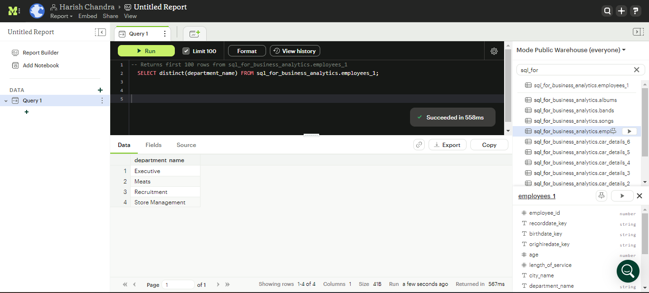

**select**

**distinct(department_name) FROM sql_for_business_analytics.employees_1;**

1. **We need employee id of employee and status year but named as Year with maximum years of service and show only 10 records.**

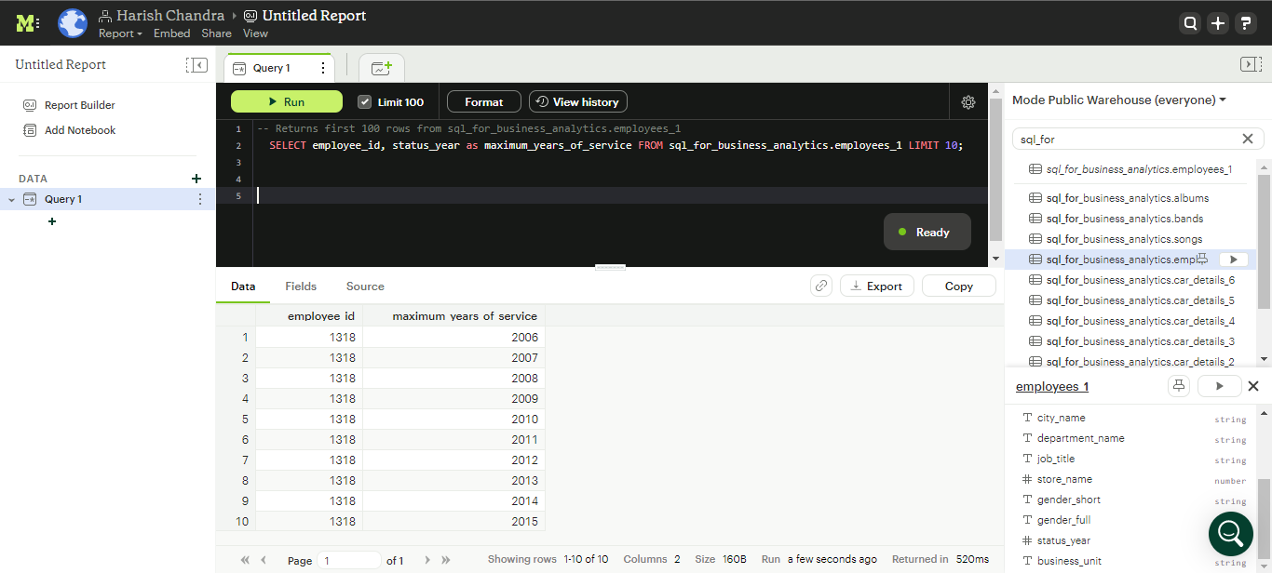

**SELECT employee_id, status_year as maximum_years_of_service FROM sql_for_business_analytics.employees_1 LIMIT 10;**

1. **Select details of employees having service length less than 20 years.**

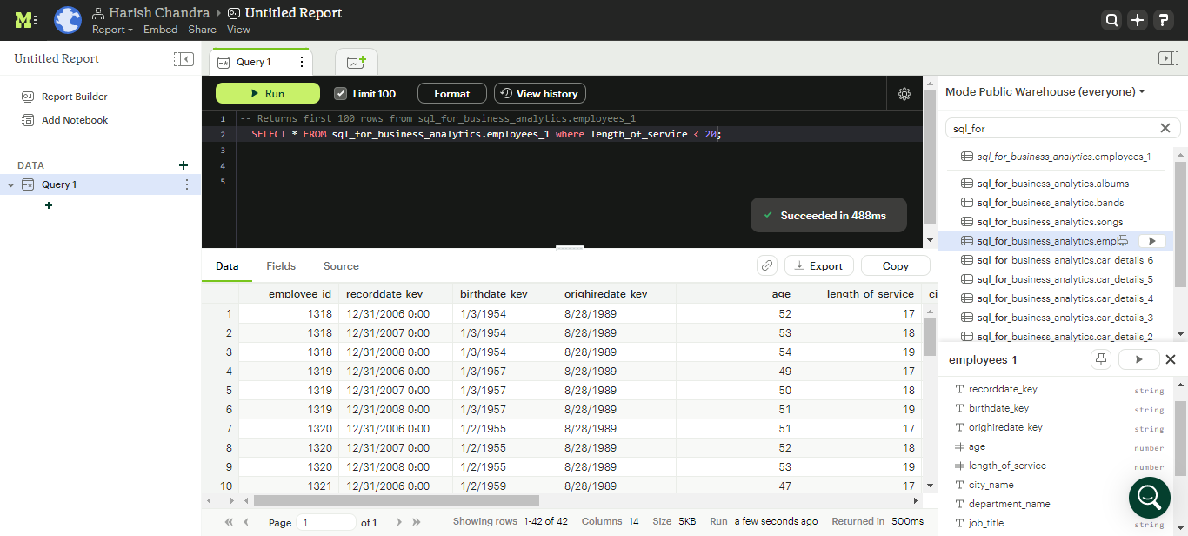

**SELECT * FROM sql_for_business_analytics.employees_1 where length_of_service < 20;**

1. **Find the employee age with less age but more years of service.**

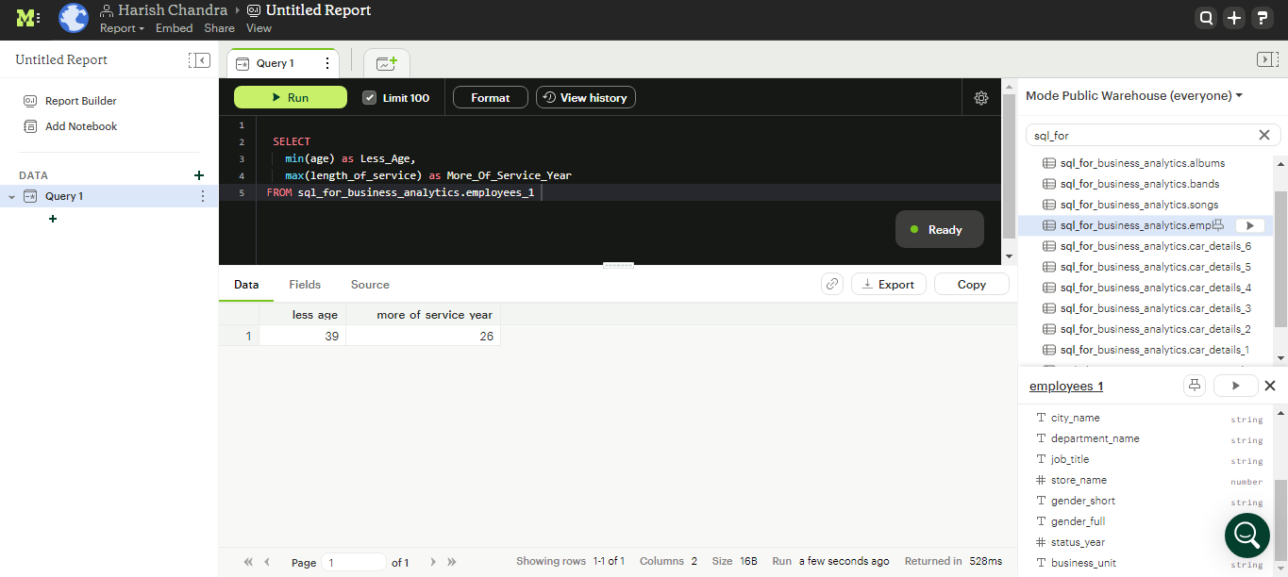

**SELECT**

**min(age) as Less_Age,**

**max(length_of_service) as More_Of_Service_Year**

**FROM sql_for_business_analytics.employees_1**

1. **Select the isolated job titles which have solemnly been terminated.**

**I am unable to solve this problem.**

**Reason - I couldn't find terminated data**

j